Alcohol and drug use during pregnancy


When a pregnant women drinks alcohol or uses drugs during her pregnancy, so does her baby. These substances can pass through the placenta and to the baby through the umbilical cord.
When a baby is exposed to substances, a number of things can go wrong. Below is a list of problems more likely to happen to babies exposed to alcohol, tobacco, and drugs:
Premature birth is a birth that takes place more than three weeks before the baby is due. Premature babies, especially those born earliest, often have medical problems.
Birth defects are problems with how a baby’s organs and body parts form, how they work, or how their bodies turn food into energy. Some birth defects need no treatment and others cause disabilities or require medical or surgical treatment.
Low birth weight is when a baby is born weighing less than 5 pounds, 8 ounces. Some low birthweight babies are healthy, even though they’re small. But being low birthweight can cause serious health problems for some babies.
Placental abruption is a serious condition in which the placenta separates from the wall of the uterus before birth. The placenta supplies the baby with food and oxygen through the umbilical cord. Placental abruption can cause very heavy bleeding and can be deadly for both mother and baby.
Fetal alcohol spectrum disorders are health problems that can happen to babies when their mothers drink alcohol during pregnancy. The most serious of these is fetal alcohol syndrome. Fetal alcohol syndrome can seriously harm your baby's brain and body.
Miscarriage is when a baby dies in the womb before 20 weeks of pregnancy. Stillbirth is when a baby dies in the womb after 20 weeks of pregnancy.
Development and behavior problems may not show up for several years after a baby is exposed to substances during pregnancy. These problems make it harder for a child to learn, communicate and get along with others, take care of her/himself, and can include attention deficit hyperactivity disorder (also called ADHD).
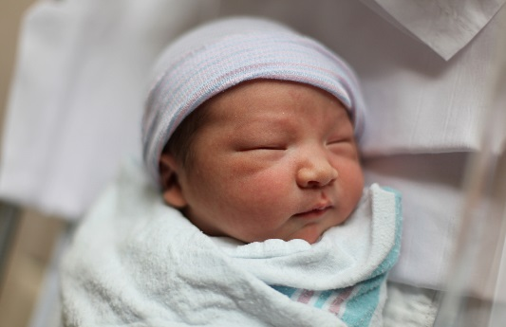
Neonatal abstinence syndrome (NAS) is a group of conditions a newborn can have if his/her mother is addicted to drugs during pregnancy. NAS happens when a baby gets addicted to a drug before birth and then goes through drug withdrawal after birth. What type and how serious an infant's withdrawal symptoms depend on the drug(s) used, how long and how often the birth mother used, how her body breaks the drug down, and whether the infant was born full term or premature.

Alcohol

There is no amount of alcohol that is proven to be safe during pregnancy. Alcohol includes wine, wine coolers, beer and liquor. You may know some women who drank regularly during pregnancy and had seemingly healthy babies. You may know some women who had very little alcohol during pregnancy and had babies with serious health conditions. Every pregnancy is different. Drinking alcohol may hurt one baby more than another. The best way to ensure a healthy baby is to stay away from alcohol altogether.
Your liver works hard to break down the alcohol in your blood. But your baby's liver is too small to do the same and alcohol can hurt your baby's development. That's why alcohol is much more harmful to your baby than to you during pregnancy.
Drinking alcohol during pregnancy can cause birth defects, miscarriage, premature birth, stillbirth, development and behavior problems, low birth weight, and fetal alcohol spectrum disorders.

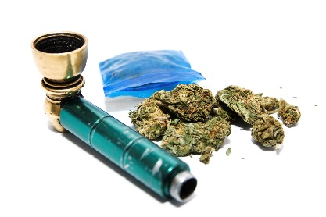
Marijuana
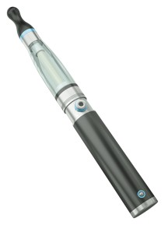
No amount of marijuana has been proven safe to use during pregnancy. Using marijuana over a long time may raise the risk of premature birth. Some children born to women who used marijuana during their pregnancies are more likely to have certain development and behavior problems. More research is needed, however, to know if these effects come from marijuana use or related her factors, like a poor home environment or the mother's use of other drugs.
Some women use marijuana to treat nausea (sick stomach) during their pregnancy. Women thinking about using medical marijuana while pregnant should check with a health care provider first.
Nursing mothers are advised not to use marijuana. THC (the main chemical in marijuana) can gather in breast milk in high amounts if a pregnant mother uses marijuana often. Some studies show that exposure to THC through breast milk could result in less ability to control body movement at 1 year of age. Because a baby's brain is still forming, THC could affect how the brain grows. New mothers using medical marijuana should talk about their use with the doctor caring for their baby.

Cocaine (coke) and Methamphetamine (meth)
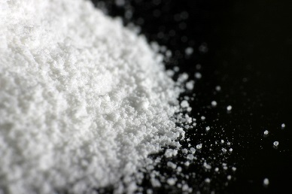
Both cocaine and meth are white powders that are eaten, snorted or mixed with liquid and injected with a needle. Sometimes meth comes as a pill or is made into a clear or white shiny rock (called crystal meth) that can be smoked.
Cocaine use during pregnancy makes premature birth, low birthweight, miscarriage and placental abruption more likely to happen.
One study found that babies of women who used meth were more than three times as likely to grow poorly before birth. Even when born at term, these affected babies tend to be born with low birthweight and have a smaller-than-normal head circumference.
Use of meth during pregnancy also increases the risk of premature birth and placental abruption. There also have been cases of birth defects, including heart defects and cleft lip/palate, in exposed babies, but researchers do not yet know whether the drug contributed to these defects.
After delivery, some babies who were exposed to meth before birth appear to undergo withdrawal-like symptoms, including jitteriness, drowsiness and breathing problems.

Heroin (smack, junk)
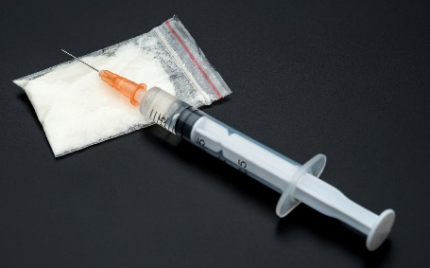
Heroin is a street drug made from poppy plant seeds. It can be a white or brown powder, or it can be a black, sticky goo. Heroin usually is injected with a needle, but it can be smoked or snorted.
Using heroin during pregnancy can be dangerous, even deadly. It may cause serious problems, including: birth defects, placental abruption, premature birth, low birthweight and stillbirth.
If you’re pregnant and using heroin, don’t stop taking it without getting treatment from your health care provider first. Quitting suddenly (sometimes called cold turkey) can cause severe problems for your baby, including death. Your health care provider or a drug-treatment center can treat you with drugs like methadone or buprenorphine. These drugs can help you gradually reduce your dependence on heroin in a way that’s safe for your baby.

MDMA (ecstasy, molly)
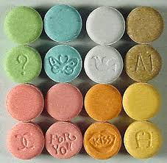
MDMA comes as a pill. It’s sometimes called the “love drug” because it makes some people feel very friendly and touchy-feely. It also can make people feel depressed or confused and have a hard time remembering things.
What little research exists on the effects of MDMA use in pregnancy suggests that prenatal MDMA exposure may cause learning, memory, and motor problems in the baby. More research is needed on this topic.

This document is available at www.sbirtoregon.org. Information used with permission from the March of Dimes and compiled from the National Institute on Drug Abuse; National Institutes of Health; U.S. Department of Health and Human Services. All images licensed for use.

