Adult Prescription Drug Abuse
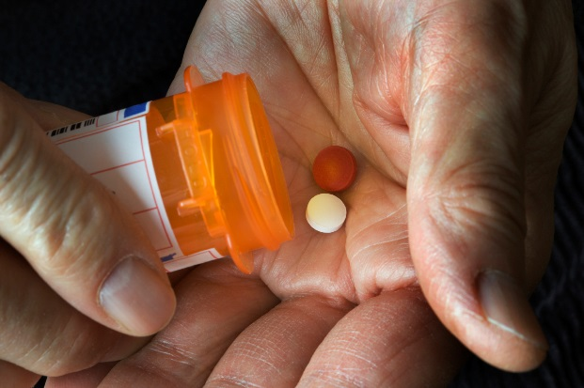
Using medications without a prescription is called drug abuse. Using meds in ways other than prescribed by a doctor is also drug abuse. So is using these drugs just to feel their effects.
Abuse of prescription drugs is common, and can lead to problems. More and more people are getting addicted to prescription drugs, go to the emergency room, or die from overdose.
At first, people may decide for themselves whether to abuse prescription drugs. But drug abuse can take over someone’s life. Over time, a person may have less power to decide for themselves whether or not to abuse drugs.
Studies show the parts of our brains that make choices are can change by long term drug abuse. These changes may help explain why addiction to drugs is so hard to beat.
Drug abuse can make things that used to be fun less fun. Someone may need to abuse drugs just to feel normal. People with heavy drug abuse can reach a point where they seek and take drugs, even if it causes problems for themselves and loved ones.

There are three main groups of prescription drugs that people abuse:

Stimulants (Adderall, Ritalin)
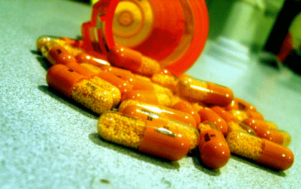
Stimulants are prescribed by doctors to help patients with ADHD focus and pay attention. Many people may think stimulants are safe to abuse. Students and people who play sports, for example, may use stimulants to perform better. However, like other prescription drugs, there are risks to abusing stimulants.
Some problems that can happen from abusing stimulants:
Long term abuse:
- Hard time breathing
- Cold sweats, rapid heartbeat, fever
- Blurred vision, hallucinations
- Addiction, withdrawal symptoms
Short term abuse:
- Sleep disorders, mood swings
- Anxiety
- Headache
- Loss of appetite, problems having sex

Opioids (Vicodin, OxyContin, Percocet, morphine, codeine)
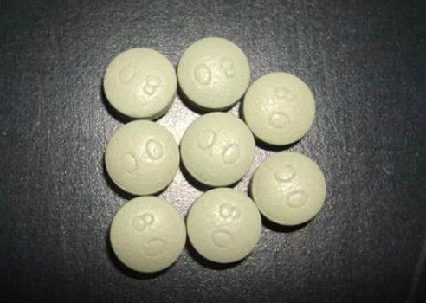
Opioids are meds that help patients deal with pain. They can also create a sense of numbness in the body and mind. High doses can create a short-lived feeling of euphoria and feeling sleepy. These effects can make stop using these drugs hard. Effects may depend on the method of taking these drugs, such as by swallowing, injecting, or smoking. Abuse of opiods may open the door to heroin use.
Some problems that can happen from using opioids:
Long term abuse:
- Brain damage
- Increased sensitivity to pain
- Weakened immune system
- Addiction, withdrawal symptoms

Short term abuse:
- Drowsiness and confusion
- Nausea and constipation
- Itching
- Large dose: slow breathing and death

Depressants (Valium, Xanax, tranquilizers, sleeping pills, benzos)
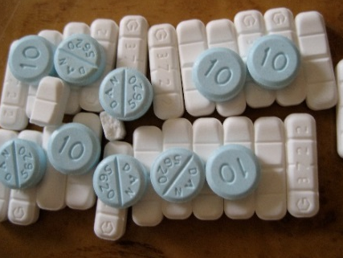
Depressants are drugs that slow down the brain. Doctors may prescribe them for patients with anxiety and sleep problems because they make a drowsy or calming effect. When other drugs like opiates or alcohol are used at the same time, a dangerous effect can happen, even with a smaller dose of depressants.
Some problems that can happen from abusing depressants:
Long term abuse:
- Memory loss
- Depression
- Heart problems, hard time breathing
- Coma
- Addiction, withdrawal symptoms
Short term abuse:
- Drowsiness, confusion
- Stomach cramps, constipation
- Anxiety, irritation
- Heart beats faster than normal
- Large dose: slowed breathing and death


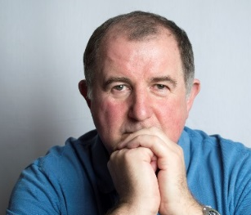



Substance use disorders

Substance use disorders are medical conditions that health professionals can diagnose when a patient’s drug use causes distress or harm. Below is a list of signs that can point to a substance use disorder. See if any of these signs apply to you.
In the past year, have you:
❑ Had times when you used drugs more, or longer, than you intended? More than once wanted to cut down or stop using drugs, or tried to, but couldn’t?
❑ More than once been in situations while or after using drugs that increased your chances of getting hurt (such as driving, using machines, walking in a dangerous area, or having unsafe sex)?
❑ Had to use drugs much more than you once did to get the effect you want? Or found that your usual use of drugs had much less effect than before?
❑ Still used drugs even though it was making you feel depressed or anxious or adding to another health problem? Spent a lot of time using drugs?
❑ Still used drugs even though it was causing trouble with your family or friends?
❑ Found that using drugs often made it harder to take care of your home or family? Or caused job troubles? Or school problems?
❑ Given up or cut back on activities that were important or interesting to you, or gave you pleasure, in order to use drugs?
❑ More than once gotten arrested, been held at a police station, or had other legal problems because of using drugs?
❑ Found that when the effects of drugs wore off you had trouble sleeping? Or had shaky hands, arms or legs? Started to sweat? Or felt things that were not there?
If items on this list apply to you, then drug use may be a cause for concern. The more items you checked on the list, the greater the need for change. A health professional can look at this list with you and help you decide what you want to do.

This document is available at www.sbirtoregon.org. Information compiled from sources including the National Institute on Drug Abuse; National Institutes of Health; U.S. Department of Health and Human Services. Images licensed for use.

