Adult Marijuana Use
What happens when I use marijuana?
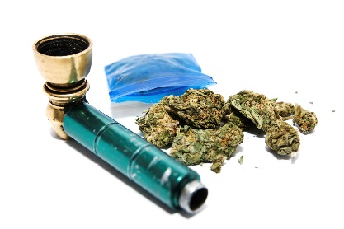
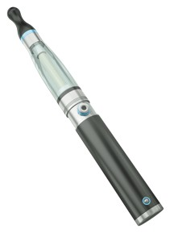
When marijuana is smoked or vaped, a person’s heart rate speeds up, breathing pathways get bigger, and blood veins in the eyes expand, making the eyes look bloodshot (red).
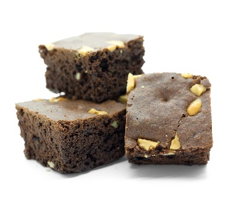
Chemicals in marijuana smoke or vapor go from the lungs into the blood and to the rest of the body and brain. The main chemical in marijuana that affects the brain is THC. Smoking or vaping marijuana makes these things happen almost right away.
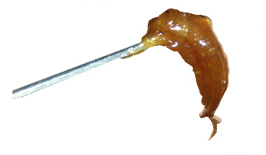
When marijuana is eaten in food or candy it takes longer to feel its effects — usually 30 minutes to 1 hour — so users may eat more THC than they wanted to.
High doses of marijuana’s active ingredients also are produced in forms that look like honey (“hash oil”), wax (“budder,”) and hard amber (“shatter”).FE
CT HEALTH?
How can marijuana affect health?

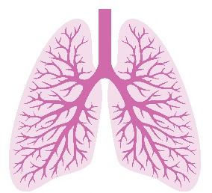
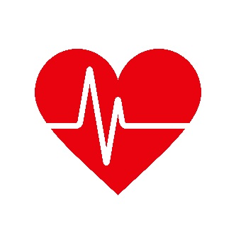
While it’s true that THC can help treat some medical problems, using marijuana can have negative effects as well.
• Toxic gases and tiny bits of matter from marijuana smoke can give you a heavy cough and hurt your lungs.
• Smoking marijuana can lead to an asthma attack for people with asthma.
• Smoking marijuana can cause lung infections, asthma and emphysema, just like with people who smoke tobacco.
• Using marijuana raises your blood pressure and makes your heart beat faster.
• During the first hour after smoking marijuana, your risk of a heart attack goes up five times more than if you didn’t smoke marijuana.
• Regular marijuana use can cause weight gain that adds stress to the heart.
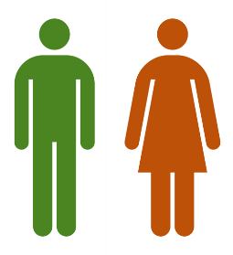
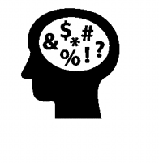
- Marijuana use may lower levels of a hormone called testosterone. This can cause mood swings, change sex drive, and make sperm count lower. Or cause problems having an erection.
- Marijuana use can cause irregular periods and lower the chance of becoming pregnant.
- Marijuana users have been shown to have higher levels of depression and more signs of depression.
- High doses of marijuana can make people see things that are not there (hallucinations), believe things that don’t make sense. (delusions), and lose a sense of who they are.
- Some people feel worried, afraid, freaked out, or not trusting of people around them when they use marijuana. Some have thoughts of suicide.
• Regular marijuana use can make it harder to pay attention, learn new things, or remember things that just happened.
• THC affects the part of the brain that makes choices. Using marijuana can lead to risky choices, like drinking and driving.

How does marijuana use affect driving?

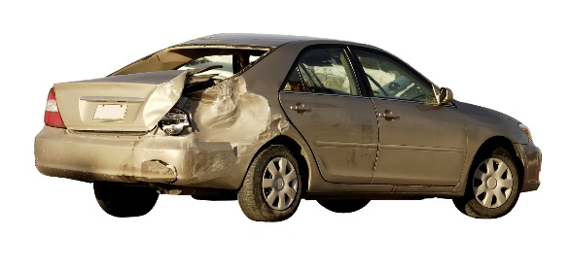
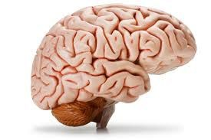
It’s not safe to drive under the effects of marijuana. Marijuana use affects a number of skills needed for safe driving: being alert, paying attention and coordination. Marijuana makes it hard to know how far away things are. You are less likely to react to signals and sounds on the road when using marijuana. Marijuana is the most common recreational drug involved in deaths from car crashes.
Studies show the risk of being in a car crash is twice as much when a driver uses marijuana.
Drivers in car crashes who have THC in their blood are more likely to have caused the crash than drivers who had not used drugs or alcohol. Using marijuana and alcohol at the same time before driving is more risky than using only one drug by itself.






Can I become addicted to marijuana?
Yes. Nearly 1 out of 11 people who tries marijuana becomes addicted to it. For those who start using in their teens, 1 in 6 becomes addicted. And for daily users, the rate is even higher.
Substance use disorders are medical conditions that doctors can diagnose when a patient’s marijuana or other drug use causes distress or harm. Below is a list of signs that can point to a substance use disorder. See if any of these signs apply to you.
In the past year, have you:
❑ Had times when you used marijuana more, or longer, than you intended? More than once wanted to cut down or stop using marijuana, or tried to, but couldn’t?
❑ More than once been in situations while or after using marijuana that increased your chances of getting hurt (such as driving, using machines, walking in a dangerous area, or having unsafe sex)?
❑ Had to use marijuana much more than you once did to get the effect you want? Or found that your usual use of marijuana had much less effect than before?
❑ Still uses marijuana even though it was making you feel depressed or anxious or adding to another health problem? Spent a lot of time using marijuana?
❑ Still used marijuana even though it was causing trouble with your family or friends?
❑ Found that using marijuana often made it harder to take care of your home or family? Or caused job troubles? Or school problems?
❑ Given up or cut back on activities that were important or interesting to you, or gave you pleasure, in order to use marijuana?
❑ More than once gotten arrested, been held at a police station, or had other legal problems because of using marijuana?
❑ Found that when the effects of marijuana wore off you had trouble sleeping? Or had shaky hands, arms or legs? Started to sweat? Or felt things that were not there?
If things on this list apply to you, then marijuana may be a cause for concern. The more items you checked on the list, the greater the need for change. A health professional can look at this list with you to see if a substance use disorder is present and help you decide what you want to do.

This document is available at www.sbirtoregon.org. Information compiled from sources including the National Institute on Drug Abuse; National Institutes of Health; U.S. Department of Health and Human Services. Images licensed for use.
.

