Adult Alcohol Use
Ready to cut back your drinking?

If so, start by filling out your plan below.

Goal: I want to cut back my drinking to no more than ______ drinks per week and no more than ______ drinks per day. (The low-risk drinking limits are found on the next page).

Reasons: My biggest reasons to cut back my drinking are: ____________________________________________________________________________________________________________________________________________________________________________________________________________________________________
Strategies: I will use these strategies to help cut back my drinking (the next page can help): ____________________________________________________________________________________________________________________________________________________________________________________________________________________________________
People: The people who can help me are (names and how they can help): ________________________________________________________________________________________________________________________________________________________
Signs of success: I will know my plan is working if: ________________________________________________________________________________________________________________________________________________________
Possible roadblocks: Some things that might make it hard and how I’ll handle them: _______________________________________________________________________________________________________________________________________________________________________________________________________________________________________

Strategies to cut back

Find different things to do. If drinking takes up a lot of your time, you can fill free time by thinking of new, healthy things to do. Hobbies you enjoy, making new friends, or spending more time with friends you’ve missed. If you are used to drinking to feel more relaxed with others, or cope with feeling sad or angry, or deal with problems, you can seek other, healthy ways to deal with those areas of your life.
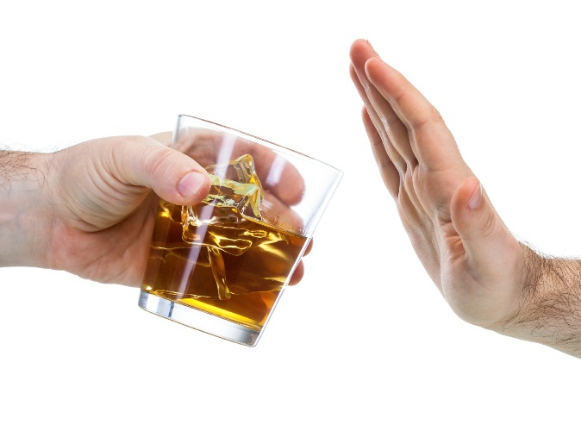
Avoid “triggers.” What triggers your urge to drink? If some people or places make you drink even when you don’t want to, try to avoid them. If certain things you do, certain times during the day, or certain feelings trigger the urge to drink, plan something else to do instead of drinking. If drinking at home is a problem, keep little or no alcohol there.
Know your “no.” You’re likely to be offered a drink at times when you don’t want one. Have a polite, firm “no, thanks” ready. The faster you can say no to these offers, the less likely you are to give in. If you pause, it allows you time to think of reasons to go along and drink.
Plan to handle urges. When you cannot avoid a trigger and you feel an urge to drink, think of these choices: Remind yourself of your reasons for changing (it can help to carry them on paper or email them to yourself). Or talk things through with someone you trust. Or get involved with a healthy, different thing to do, such as exercise or a hobby. Or, instead of fighting the urge to drink, wait for it to go away without giving in, knowing that it will soon pass.
These four strategies are helpful. But if you think you may be addicted to alcohol and want to stop drinking, don’t do it alone. It can be dangerous to all of a sudden stop drinking when you are addicted to alcohol or are a heavy drinker. Seek medical help to make a safe plan.
Low-risk drinking limits:

 | Drinks per week | Drinks per day
Men | 14 | 4
Women | 7 | 3
Age 65 or older | 7 | 3
Pregnancy | 0 | 0

Drinking tracker cards

DS
If you want to cut back on your drinking, start by keeping track of every drink. Below are two forms you can cut out and keep with you. The “4-week tracker” is a simple calendar form that helps make you aware of drinking patterns - a key step in planning for a change.

If you mark down each drink before you have it, this can help you slow down if you need to.

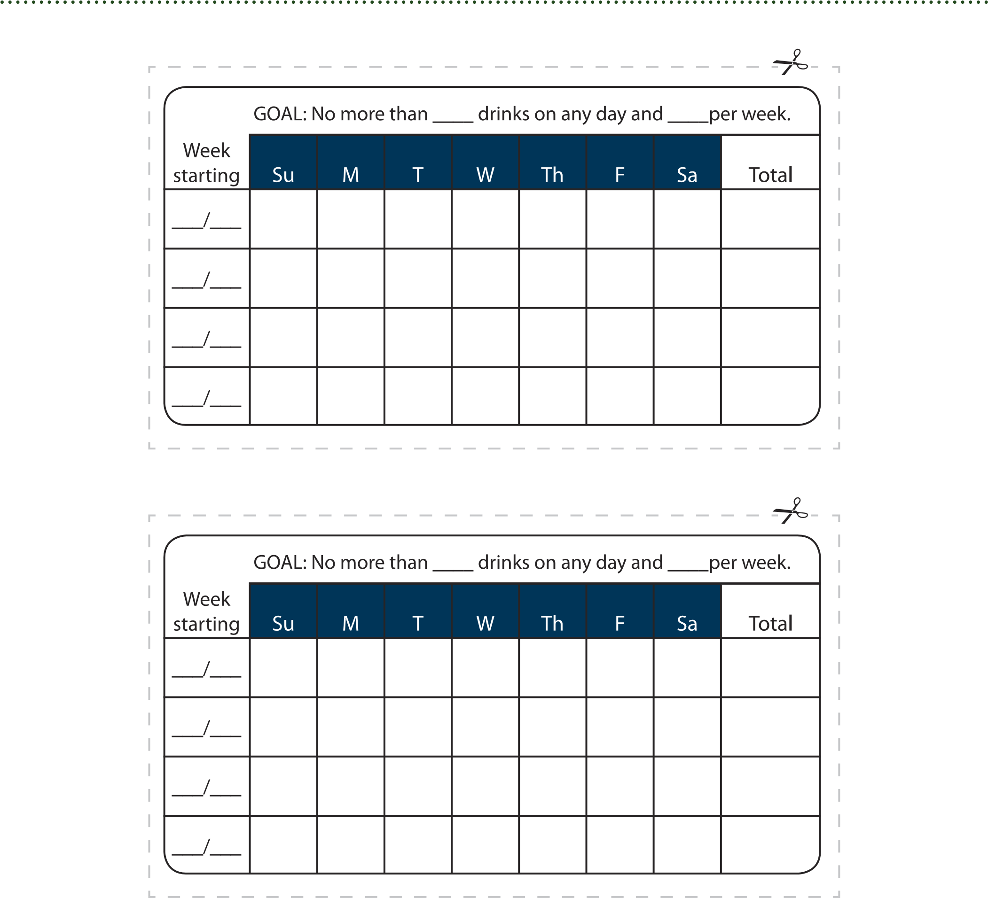

This document is available at www.sbirtoregon.org. Information compiled from the National Institute on Alcohol Abuse and Alcoholism (NIAAA), July 2015 and used with permission. NIAAA does not endorse any particular organization, product, or service. Images used with permission or licensed for use.

