Adult Alcohol Use
What is risky drinking?

Do you enjoy a drink now and then? Many people do, often with friends and family. However, drinking enough alcohol over time can create new health problems or make current health problems worse. Risky drinking means drinking more than the number of drinks shown below:

Low-risk drinking limits:
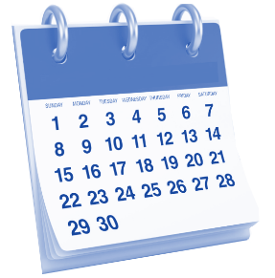
 | Drinks per week | Drinks per day
Men | 14 | 4
Women | 7 | 3
Age 65 or older | 7 | 3
Pregnancy | 0 | 0

Men have to drink more than women to become risky drinkers because they weigh more, on average. Also, women have less water in their bodies, making it easier to be harmed by alcohol even when they drink the same amount as men. What counts as a drink? See below.

One drink is:

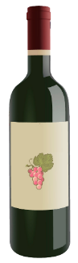
8 ounces of malt liquor
5 ounces of wine
12 ounces of regular beer
A bottle of wine is 5 drinks
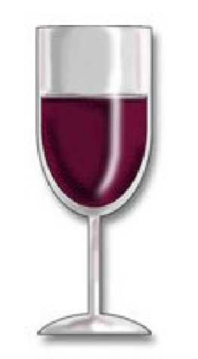
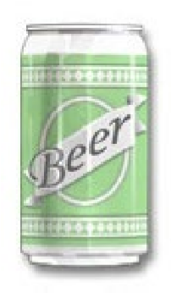
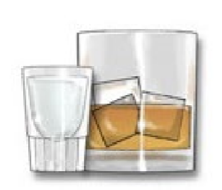
1.5 ounces of liquor
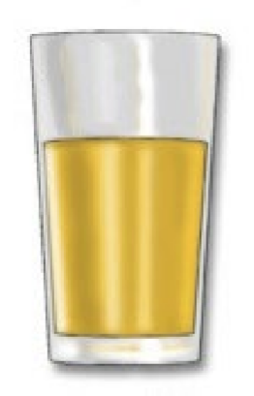

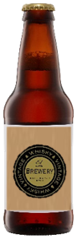

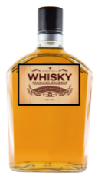
A pint of liquor is 11 drinks
(80 proof)
40 ounces of malt liquor is 4 and-a-half drinks

Do you think you might drink above low-risk limits? Do you think most people do? Below are results from a survey of 43,000 adults in the U.S.A.:

28% of people drink above low-risk limits
37% of people drink below low-risk limits
35% of people don’t drink at all
WHAT’S CAN GO WRONG FROM RISKY DRINKING?
What can go wrong from risky drinking?
These are some of the problems that can happen with risky drinking:
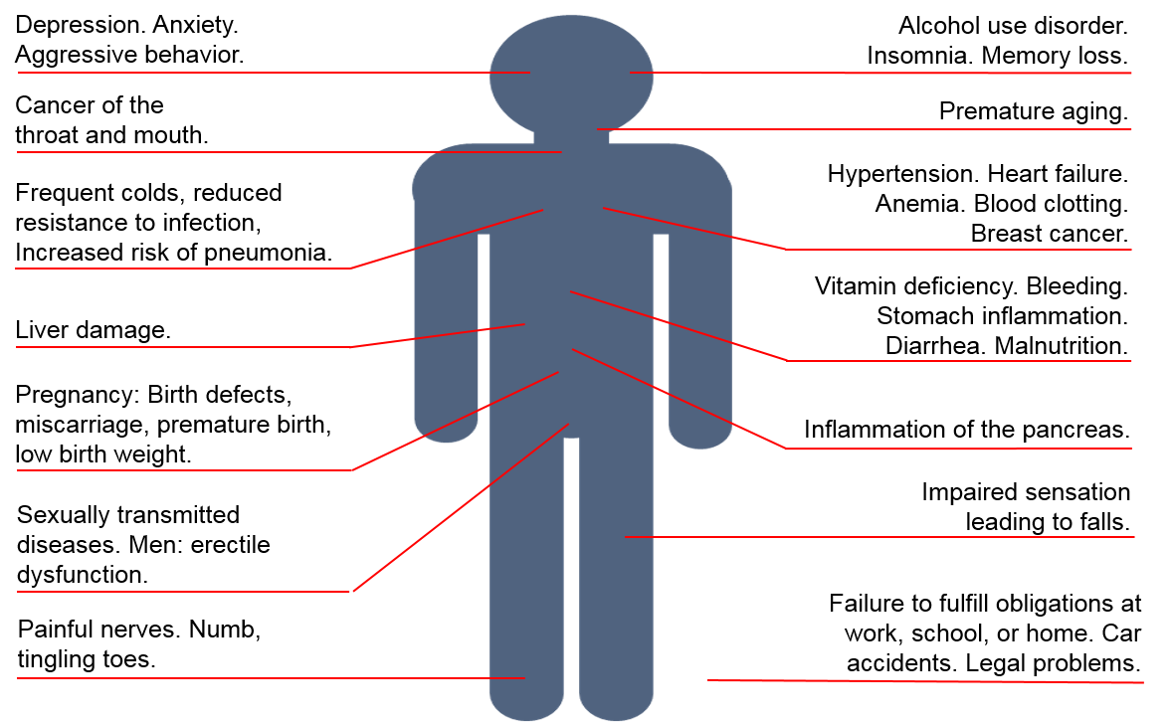

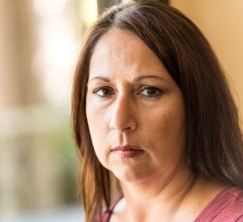
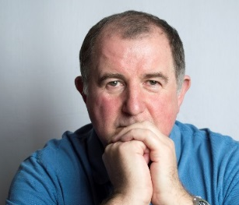



What is an alcohol use disorder?

Alcohol use disorders used to be called alcoholism or alcohol abuse. In the U.S.A., about 18 million people have an alcohol use disorder. Below is a list of things that happen when someone has an alcohol use disorder. See if any of these apply to you.

In the past year, have you:

❑ Had times when you drank more, or longer, than you wanted to? More than once wanted to cut down or stop drinking, or tried to, but couldn’t?
❑ More than once been drinking and could have gotten hurt (while driving, swimming, using machines, walking in a bad part of town, or having unsafe sex)?
❑ Needed to drink much more than you used to feel its effects? Or noticed that your normal number of drinks had much less effect than before?
❑ Still drank even though it was making you feel depressed or anxious or adding to another health problem? Or after having a blackout? Have you spent a lot of time drinking? Or being sick or having a hangover?
❑ Still drank even though it was causing trouble with your family or friends?
❑ Noticed that drinking—or being sick from drinking—often made it harder to take care of your home or family? Or caused job troubles? Or school problems?
❑ Given up or cut back on things that were important or interesting to you, or gave you pleasure, in order to drink?
❑ More than once been arrested, been held at a police station, or had other legal problems because of your drinking?
❑ Noticed that when the alcohol was wearing off, you had trouble sleeping, or began to shake, felt restless, felt sick to your stomach, began sweating, felt your heart beating fast, or has a seizure? Or felt things that were not there?

If these things are not happening to you, then staying below the low-risk drinking limits will reduce your chances of having problems in the future. If these things are happening to you, then alcohol may be a problem. The more things that are happening to you, the more the need for change. A professional can talk about this list with you to see if you have an alcohol use disorder and help you decide what you want to do.

This document is available at www.sbirtoregon.org. Information compiled from the National Institute on Alcohol Abuse and Alcoholism (NIAAA), July 2015 and used with permission. NIAAA does not endorse any particular organization, product, or service.

