Adolescent illegal drug use

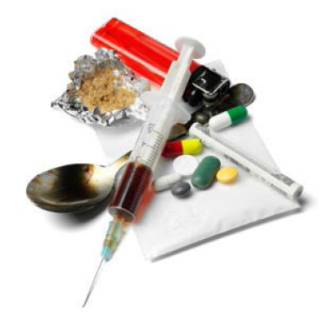
At first, people may decide for themselves whether to use illegal drugs. They may see what they like about drug use, and think that they can control their drug use.
However, drug use can take over someone’s life over time. A person may have less power to decide for themselves whether or not to use drugs. Studies show the parts of our brains that make choices are affected by heavy drug use. How we learn and remember things can change from using drugs. These changes may be why addiction to drugs is so hard to beat.
Drug use can make things that used to be fun less fun. A user may need to use drugs just to feel normal. People with heavy drug use can reach a point where they seek and take drugs,
even if it causes problems for themselves and loved ones.

Some risks of occasional or short term drug use
- Aggression and violence
- Unsafe sex, forced sex
- Sleep problems
• Throwing up, fever, confusion
• Overdose, blackout
• Hurting yourself by accident

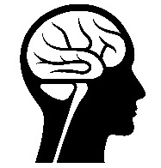
Some risks of heavy or long term drug use
- Trouble with the law
- Problems with family, friends, or at work
- Tolerance (needing larger doses to get the same effect)
- Withdrawal symptoms from quitting
- Mental health problems
- Anxiety, depression, mood swings
- Money problems

Some risks of injecting drugs

- Addiction
- Overdose
- Vein collapse
- Infection

- Sores and ulcers
- HIV
- Hepatitis

Cocaine (coke)
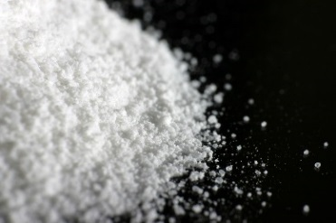
Cocaine is a powerfully addictive drug made from the leaves of the coca plant native to South America. Cocaine comes in a white powder or processed to make a rock crystal that people smoke.
Cocaine can create a feeling of intense pleasure and increased energy. After the "high" of the cocaine wears off, many people experience a "crash" and feel tired or sad for days. They may also feel a strong craving to use cocaine again to try to feel better. But with repeated use, cocaine can reduce a person’s ability to feel any pleasure at all. People may try to make up for it by taking more and more of the drug to feel the same pleasure.
Deaths from cocaine use are often a result of the heart stopping (cardiac arrest) followed by stopped breathing. Cocaine can be deadly when taken in large doses or when mixed with other drugs or alcohol.
Methamphetamine (meth)
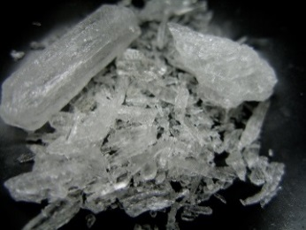
Methamphetamine—known as “meth”—is a very addictive stimulant drug that appears as a white, bitter-tasting powder. Sometimes it's made into a white pill or a shiny rock called a crystal. Meth can boost mood, and increase energy, but it also has dangerous effects like raising heart rate and blood pressure. Smoking or injecting meth works quickly, but the pleasure fades quickly too, users often take more doses, in a “binge and crash” pattern.
Using meth over time may cause effects that last even after a person quits using the drug. These effects include: anxiety and confusion, problems sleeping, mood swings, acting violently, skin sores from scratching, and dental problems.
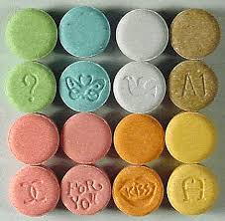
MDMA (ecstasy, molly)
MDMA is is an illegal, man-made drug popular in the nightclub scene at music festivals or concerts. People who use MDMA might feel very alert, or “hyper,” at first. Some lose a sense of time and have other changes in perception, such as a more intense sense of touch. Users may feel a greater sense of closeness and empathy to others.
However, some users feel negative effects. They may become anxious and nervous, become sweaty, have chills, or feel faint or dizzy. Even those who don’t feel negative effects during use can experience negative effects afterwards, such as confusion, depression, sleep problems, drug craving, and anxiety. It is unknown if MDMA causes long-term brain changes in people who use over time.

Hallucinogens (LSD, mushrooms, PCP)
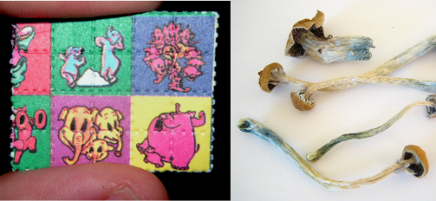
Hallucinogens are drugs made from certain plants and mushrooms. Hallucinogens cause people to see things, hear sounds and feel things that seem real but do not exist. These drugs produce quick, intense mood swings - users may feel several emotions at the same time. The effects can vary greatly from person to person and from amount taken.
People who use these drugs may have a hard time focusing, communicating, or telling the difference between what is real and what’s not. They may hear voices, see images, and feel things that do not exist. It’s not certain if the brain is changed forever from hallucinogen use, but some people who use them appear to develop chronic mental disorders.

Inhalants (poppers, whippets, laughing gas, snappers)
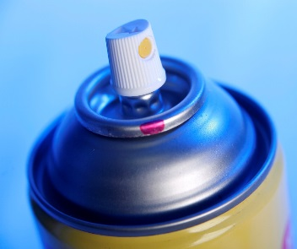
Inhalants are chemicals found in products around the house or at work. that people inhale on purpose to get “high.” Users may “sniff” or “snort” fumes or spray aerosols directly into the nose or mouth. Sometimes the substance is sprayed or placed into a bag first (“bagging”). Some users “huff” from an inhalant-soaked rag stuffed in the mouth or inhale from balloons filled with nitrous oxide.
Because the “high” lasts only a few minutes, people who use inhalants often try to make the feeling last longer by inhaling repeatedly over several hours.
Inhaling certain fumes, even just once, can be very harmful to the brain and body and can lead to death. The chemicals found in these products can change the way the brain works and can cause serious harm to vital organs and systems.

Heroin (smack, junk)
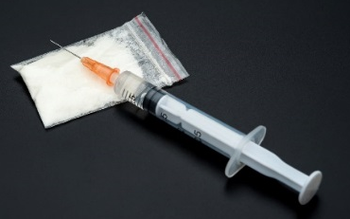
Heroin (also called smack or junk) is a street drug made from poppy plant seeds. It can be a white or brown powder, or it can be a black, sticky goo. Heroin usually is injected with a needle, but it can be smoked or snorted. Heroin’s color and look depend on how it is made and what else it may be mixed with. It can be white or brown powder or a black, sticky substance called “black tar heroin.”
Heroin use can cause feeling sick to the stomach and throwing up, severe itching, slowed (or even stopped) breathing. There is an increased risk of HIV and hepatitis (a liver disease) through shared needles.
In addition to the effects of the drug itself, heroin bought on the street often contains a mix of substances, some of which can be toxic and can clog the blood vessels leading to the lungs, liver, kidney, or brain. This can cause permanent damage to those organs.

This document is available at www.sbirtoregon.org. Information compiled from the National Institute on Drug Abuse; National Institutes of Health; U.S. Department of Health and Human Services. All images are licensed for use.

